**SMART WATER DISPENSER**

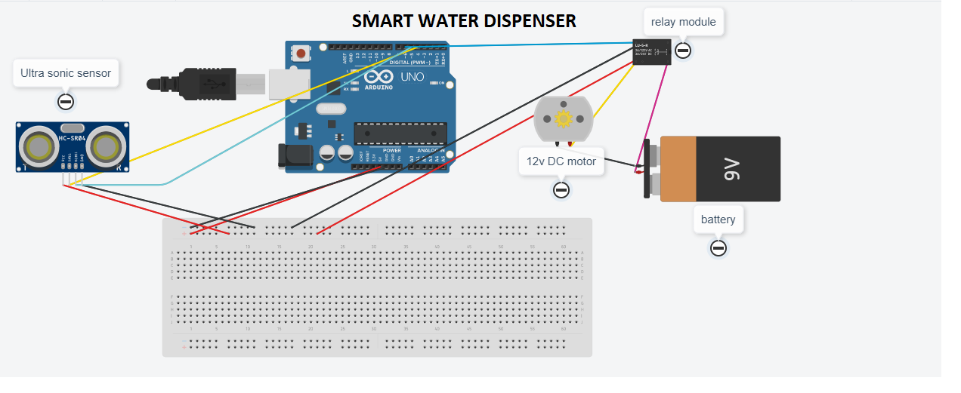

Materials Required

* Arduino Uno (any version)
* HCSR04 – Ultrasonic Sensor
* 5v relay
* 12v motor
* 12v adapter
* Breadboard
* Connecting Wires

### Working Concept

* The Concept behind the **Smart Water Dispenser** is very simple. We will use a **HCSR04 Ultrasonic Sensor** to check if any object such that the glass is placed before the dispenser, the object (glass) will be filled with the water with the help of a Dc motor.

DONE BY:

M. TEJA VARDHAN

Y.SAI TEJA